Assessment Strategy

Multiple-Hurdle Assessment Process
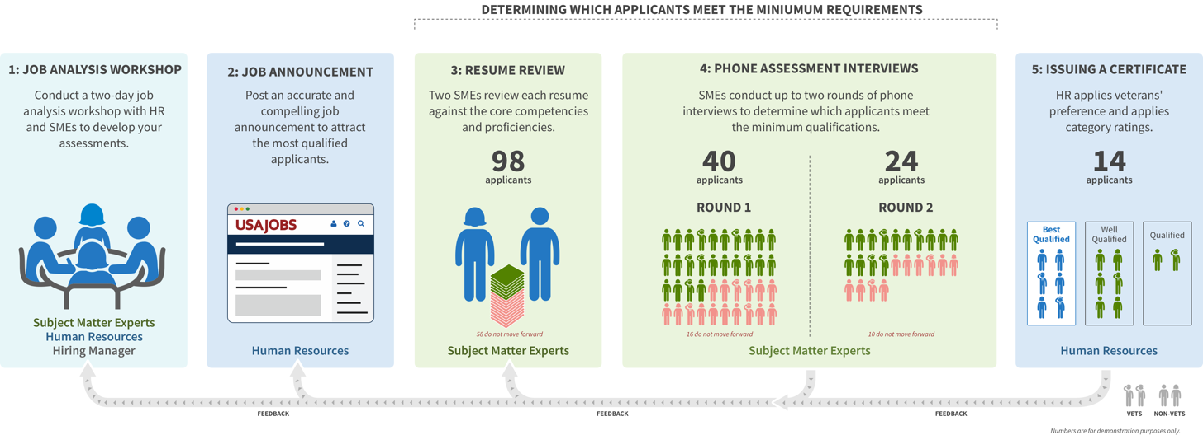

See “Understanding the SME-QA Process” for more details on how this process compares to more typical DE hiring actions.

Job Analysis
Based on job tasks performed in these positions, SMEs, HR, and Hiring Managers will come together to professionally develop the competencies, proficiency levels, and structured interview questions that will define the assessments. SMEs will use this package to conduct technical evaluation during the process.

Job Announcement
The Job Announcement (JOA) will inform applicants that only the first __ pages of their resume will be reviewed. However, SMEs can use the first __ pages of work experience should work experience not be listed until page two based on the use of the USAJOBS Resume Builder technology or another formatting issue.

This DE job announcement will close on midnight the day the number of applicants reaches ___, thus total applicants may exceed ___. It will otherwise be open for a week.
[OPTIONAL – REMOVE IF NOT REQUIRED]
The job announcement will require an applicant to submit a _____work sample/design portfolio______ in order to be considered.

Pre-Qualification Resume Review
HR will review all resumes to remove applicants whose applications are ineligible for federal employment due to not being a U.S. citizen or not attaching both a resume and work sample (if required). The process does not use the self-assessment portion of the occupational questionnaire, and therefore there are no self-assessment questions for HR or SMEs to review.
For remaining applicants, their resumes and work samples (if required) will be reviewed by SMEs. Two SMEs will independently give a rating of Move Forward or Does Not Move Forward. A third SME may be needed to break a tie between the first two SME assessments if they did not agree.

Resume Review Ratings
- Move Forward: Required competencies and proficiency levels adequately reflected to warrant further evaluation.
- Does Not Move Forward: Required competencies and proficiency levels not adequately reflected.

Resume Review Outcomes
SME1 Rating | SME2 Rating | Resume Review Outcome
Move Forward | Move Forward | Move Forward
Move Forward | Does Not Move Forward | Tiebreaker Needed
Does Not Move Forward | Does Not Move Forward | Does Not Move Forward

In the event of a tie, the tiebreaker makes the final decision.

HR Resume Review
When the SME resume review is complete, HR will ensure SMEs have provided necessary justification to later retrace the decision if needed. The burden of the justification will be limited to stating at least one competency or proficiency that is not reflected in the resume based on the SME’s expertise. The SME will add a line explaining why they feel it is not reflected for HR to review and for the case file.
If documentation is lacking, HR will work to ensure SMEs enhance their justification statement without second guessing the judgment of someone with expertise in the field.
Good examples:
Move Forward: Required competencies and proficiency levels adequately reflected to warrant further evaluation. Duration of experience is met.
Does Not Move Forward: Though Eugene’s resume shows 43 years experience as an IT Specialist at the GS13 level, there is no evidence that he is experienced at {COMPETENCY 1} at the levels required by the position because there is no evidence of any successful outcomes.”
Rather than writing sentences from scratch, this hiring action may make use of an SME Resume Review tool which has all technical specialized experience listed in a checkbox format. Once an SME says one is missing, they do not need to complete the rest of the checklist. If an SME says one is missing they will be prompted to write a sentence or two explaining why the competency or proficiency level was missing.
After resume review, HR will contact applicants via their talent acquisition system if they are not moving forward, or if they are moving forward to notify them about next steps for their interview. Passing resume review and being minimally qualified only gains applicants entry into the qualifying interview stage. It does not mean applicants are qualified and eligible for preference.
Finally, when the scheduler emails the applicants instructions on how to schedule a time slot for their interview, the applicants will be told that the first round of phone interviews must take place within a given timeframe (e.g. 8 business days) in order for the applicant to be considered for the position. In addition, applicants will be instructed that they should respond within a stated number of business days to schedule their interview in order to remain in consideration.

Passing Score Interviews
The interviews determine which applicants meet the competencies and proficiency levels to determine who is qualified and eligible for preference.
As explained in "Understanding the SME-QA Process," the agency's SMEs will conduct the pass/fail assessment interviews to determine which applicants do not move forward based on the applicants’ responses to the interview questions. Anyone an SME determines is unqualified based will not be added back after each round. Instead, HR will adjudicate and apply Veterans’ preference only to applicants who achieve the overall passing score after the second interview. Before that last step, the process is blind to veterans preference status and is only based on qualifications.
During each phone interview, one SME will assess the competencies and proficiency levels defined during job analysis. The SME will write thorough notes about the applicant’s answers in the structured interview question guide.
The SME assessing the applicant will provide an assessment response for each interview question that will result in the following scores:
2: Exceeds Requirements: Give the applicant a "2" if the SME determined that the applicant’s answers met all required proficiency levels for required competencies AND exceeded at least one.
1: Meets Requirements: Give the applicant a "1" if the SME determined that the applicant’s answers met the required proficiency levels for all required competencies.
0: Does Not Meet All Requirements: Give the applicant a "0" if the SME determined that the applicant’s answers did not meet proficiency levels for some or all competencies.

Any applicant receiving a 0 will be ineligible due to not being qualified. All other applicants will have their scores uploaded into USA Staffing and will transmute into categories:
Interview 1 Assessment Rating | Interview 2 Assessment Rating | Overall Outcome | Final Score
1 | 1 | Applicant Meets Qualifications | 70
1 | 2 | Applicant Meets Qualifications | 85
2 | 1 | Applicant Meets Qualifications | 85
2 | 2 | Applicant Meets Qualifications | 100
1 or 2 | 0 | Applicant Does Not Meet Qualifications
0 | N/A | Does Not Move Forward to Interview Two

HR Interview Assessment Review
After each interview round, HR will review each SME's analysis within the interview template to ensure the SME provided the necessary justification. If any documentation is lacking, HR will work to ensure SMEs complete their notes. HR will transfer the rating into the final score using the provided transmutation table above.

Preparing the Certificate
When the list of applicants who have achieved an overall passing score is complete, HR will assign those applicants to a quality category using SME interview assessment scores and apply veterans’ preference according to all current rules. HR will also ensure that the applicants who appear on the certificate are eligible at the grade level being hired for before issuing the certificate. Hiring Managers may choose to conduct additional interviews after receiving the certificate, or they can make immediate selections based on the resumes and interview transcripts.

